1. Problem Statement

The "URL Shortener API" provides the ability to shorten long URLs into shorter

1. Requirement

Accept a long URL as input and return a shortened URL

Should accept only valid URL’s

1. Endpoint

Post hostname/Api/generateShortnedUrl

1. Flow diagram

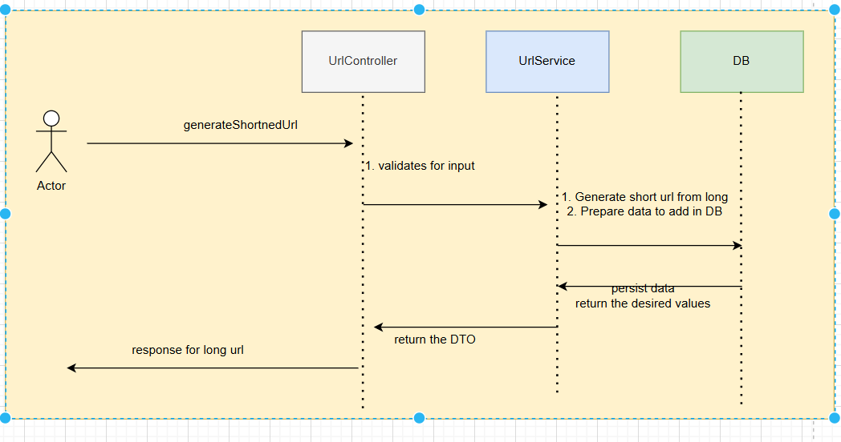

1. Example

Request :

Post host/Api/generateShortnedUrl

{

longUrl : “https://www.google.com/search?q=somelongUrl”

}

Response :

Body

{

longUrl :” https://www.google.com/search?q=somelongUrl”,

shortUrl :”dnoihowqe”

}

1. Other